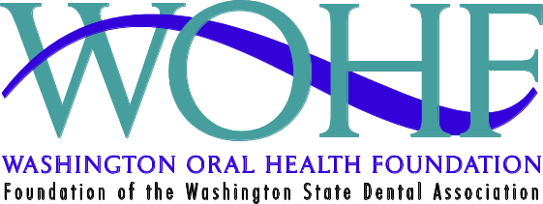

WASHINGTON ORAL HEALTH FOUNDATION
VOLUNTEER APPLICATION

STUDEN

NAME: _________________________________________________ DATE: ______________________

HOME ADDRESS: _____________________________________ HOME PHONE:_______________

CITY: __________________ STATE: ______ ZIP:_____________ HOME EMAIL:_______________

CELL PHONE: ______________________ please contact me at: Home Cell

I AM INTERESTED IN (check all that applies. Brief program descriptions are located on back):

 PRESENTING ORAL HEALTH PRESENTATIONS
_______Elementary (grades PreK-4)
_______Intermediate School (grades 5-6)
_______Middle School (grades 7-8)
_______High School (grades 9-12)

VOLUNTEERING AT A LOCAL BOYS & GIRLS CLUB

 VOLUNTEERING AT HEALTH/COMMUNITY FAIRS

My preference/limitations are: Adults Only Children Only Seniors Only Other
What languages do you speak other than English? _______________________________________________
I will be available to volunteer _________ (# times) per: week month quarter year
Which day(s) Mon Tues Wed Thur Fri Sat

CURRENT VOLUNTEERS: Do you wish to continue to be a WOHF Volunteer? Yes No

COMMENTS/QUESTIONS:_______________________________________________________________________________________________________________________________________________________
Please fax completed form to: WOHF at 206-443-9266 mail to, 126 NW Canal St., Seattle, WA 98154.

